WORD WALL CARDS
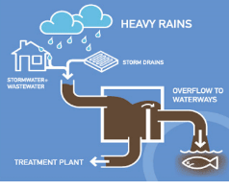
combined sewer overflow
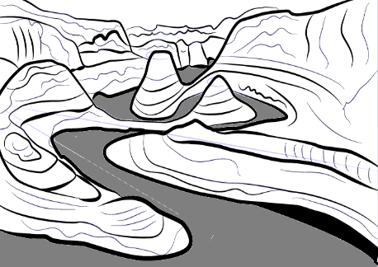
erosion
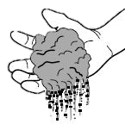
soil
urban
rain garden
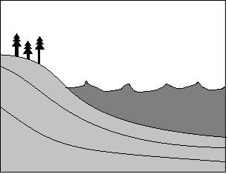runoff


ground water
pervious surface
impervious surface
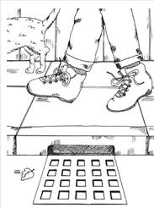
storm drain
pollution
weathering
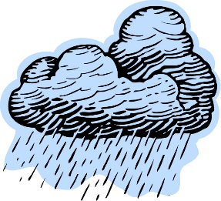
stormwater
constraints
criteria for success
problem
optimizing
stakeholder
engineer
solution
failure point
Engineering Design Process
Fair Test
Variables
Changed Variable
Controlled Variable
Measured Variable

